ByDesign and Subscription Billing

To use the SAP Business ByDesign Subscription Billing Cloud Platform Integration (CPI) scenario as a template for Customer replication or Invoice replication between Hybris and SAP Business ByDesign follow these steps. After importing the Subscription Billing integration scenario into your workspace, you will be able to make edits to the scenario.

1. Open the Cloud Platform Integration interface using the Hackathon supplied URL.
2. Click on the “Discover” icon .
3. Click “Integration”.
4. In the “Search” bar type “Subscription Billing”.

You should see:

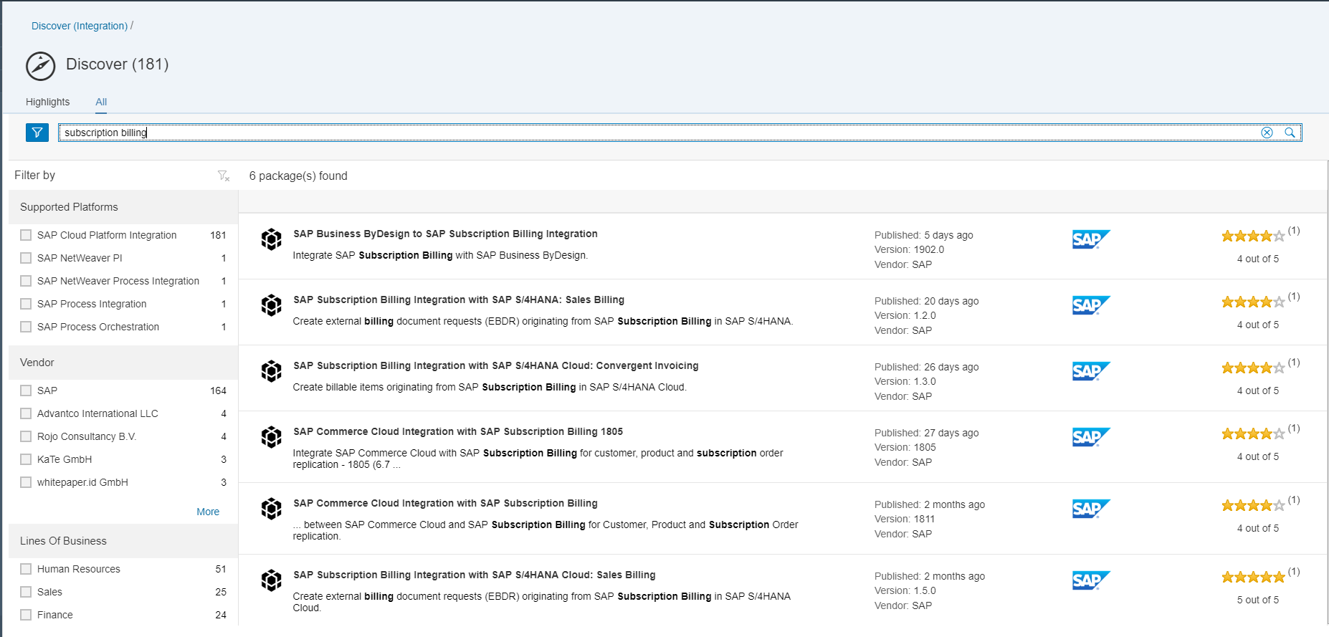

1. Click “SAP Business ByDesign to SAP Subscription Billing integration”.
2. Once the package is open, click “Copy” in the upper right corner and the package is copied to your workspace.
3. Click the “Design”  icon and click on “SAP Business ByDesign to SAP Subscription Billing Integration”.
4. Click on the “Documents” link and review the “Configuration Guide: SAP Business ByDesign to SAP Subscription Billing Integration” PDF for configuration setup information.